**USING RAPTOR – CALCULATE FIBONACCI SERIES**

**T. SUMANTH**

**192011452**

**FLOWCHART**

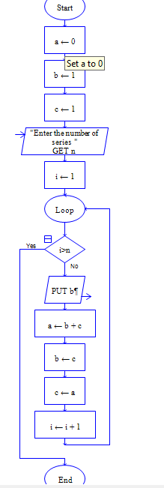

**OUTPUT**

INPUT IS 9

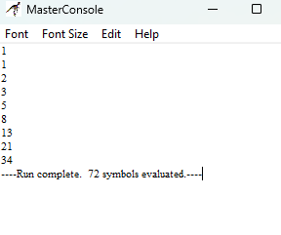

**RESULT:**

The program is executed and verified successfully